PHYSICAL PROPERTIES OF COMMON MINERALS

The Properties of Minerals:

A mineral is a naturally occurring, inorganic, crystalline material with a unique chemical structure. Given that several thousand separate minerals have been identified, it is fortunate for us that only a few are common. In fact, twelve such minerals comprise a good deal of the earth's crust. Examples of these twelve minerals are found in the boxes labeled “PART 1: MINERALS” and PART 1: MINERAL, cont.” Find these boxes in the cabinets under the display case in SC 110 (the geology study room).

The usefulness of knowing the commonly occurring minerals may be illustrated with the following example. The sample of the common rock granite (#C-1 in the Part I box) is composed of the minerals quartz (the gray mineral), potassium feldspar (the white mineral), and biotite (a flaky black mineral). Based on the identification of these three minerals and the coarse-grained texture (to be discussed later), the rock sample is identified as granite. The first three mineral specimens in the box, samples B-1, B-2, and B-5, are larger samples of the quartz, potassium feldspar, and biotite found in the granite. Note: some of our granite samples also have the mineral hornblende (= sample B-6) in addition to the biotite or instead of the biotite.

Useful properties of a mineral that aid in hand samples identification include the following:

Color - One of the most obvious properties is color. However, one must be cautious when using color as many minerals occur in many different colors (i.e., quartz may be pink, white, black, blue, green, red, purple, or colorless). Thus, color is distinctive only for some minerals, but not all.

Luster - This is a reference to the appearance of the mineral when it reflects light. Minerals that look silver, gold, bronze, or copper are said to have a metallic luster (see examples provided by your instructor). Non-metallic lusters may still shine, but they do not appear metallic. A common non-metallic luster is found in samples that have a vitreous (glassy) luster. Other lusters found in minerals include dull or earthy, and pearly (iridescent).

Reaction with HCl – Dilute hydrochloric acid HCl will react with calcite producing an effervesce (bubbles) when the HCl is dropped on the mineral. This becomes an easy method for us to determine if calcite is present as CALCITE is THE ONLY MINERAL you will see in this class that reacts with HCl.

Use this acid with caution. Do not get it in your eyes or on your clothing. If you do get acid in your eyes accidentally, flush your eyes with water and seek medical help as soon as possible. If you put acid on a sample it is your obligation to wash the sample afterward so the next person does not get acid on their hands.

Hardness - A physical property that does not change is hardness. Hardness is defined as the mineral's ability to resist scratching. For example, diamond is the hardest substance known and will scratch all other minerals. A relative scale of 1 to 10 has been established for use in mineral identification is termed the Moh's Hardness Scale (1 for talc and 10 for diamond).

Some of the more common minerals on this Moh’s Hardness Scale are:

Hardness Mineral Description
1 Talc* Very soft; easily marked by a fingernail.
2 Gypsum* Soft; easily marked by a fingernail
3 Calcite Harder than the fingernail; however may be scratched by a knife (also react to HCl).
6 Feldspar Very common mineral that scratches glass
7 Quartz Very common mineral that scratches glass

* not in minerals box- (see examples provided by your instructor)

The hardness of common objects that are useful for testing minerals include:
Fingernail 2-2.5 Copper (penny) ~3.0
Glass plate 5.5 Knife blade 5-5.5

Most of the time, we do not know the exact hardness of a mineral but we may determine a possible range of hardnesses. For example, to determine the hardness of calcite, B-11, we know that it will not scratch glass, but if we rub the mineral on our fingernail (hardness 2-2.5), we find that the mineral will scratch our fingernail. So, the mineral is between 2 and 5.5 in hardness. If a mineral will scratch glass then we know it has a hardness ≥ 5.5.

Cleavage and Fracture - When a mineral is broken it may cleave or fracture. Cleavage is created when the bonding between the rows of atoms in the mineral are weaker in some directions than others. This produces a flat surface when the sample is broken that is repeated and will usually reflect light. On the other hand, fracture is an uneven, non-repeated, breakage that indicates that the bonding between the atoms is nearly equal in all directions, so no preferred breakage occurs.

Samples B-2, B-3, B-4, B-5, B-6, B-7, B-11, and B-13 display at least some cleavage, while samples B-1, B-8, and B-10 display fracture only. In most minerals there is a combination of cleavage and fracture. Since any mineral will fracture if hit hard enough, the presence of fracture only is not a clue in determining the mineral type, but the presence of cleavages may help you identify the mineral.

Sample B-11 is the mineral calcite which displays rhombic cleavage (like a deformed cube), while quartz, B-1, displays fracture. (Aside: Notice that there are two samples of quartz in the tray. B-1a is a small crystal of quartz. It appears at first that the crystal has cleavage but the outside surfaces are crystal faces. Why are these not cleavage faces?)

In most minerals there is a combination of cleavage and fracture. For example, plagioclase feldspar, B-3, has two cleavages and the third side has fracture. Remember, you may see many cleavages, but if they are parallel (repeated) they count as one. Muscovite, B-4, is an example of a mineral with one cleavage. Notice all the parallel planes which count as one cleavage (see Figure 1).

One can describe the number of cleavages in a sample and the angle of the cleavages to each other, but the purposes of this study guide, you will only be expected to identify whether a sample has cleavage or fracture, because the presence of cleavage may help you determine the type of mineral in a rock.

In many cases, you will have to use a hand lens to see the tiny cleavage surfaces of minerals in a rock. Go back to sample C-1, the granite, and look at the minerals with the hand lens. You should notice that the quartz (the clear gray mineral) has only fracture while the potassium feldspar (the white mineral) and the biotite (the black, flaky mineral) has cleavage (some of the samples have hornblende instead of biotite as the dark mineral).

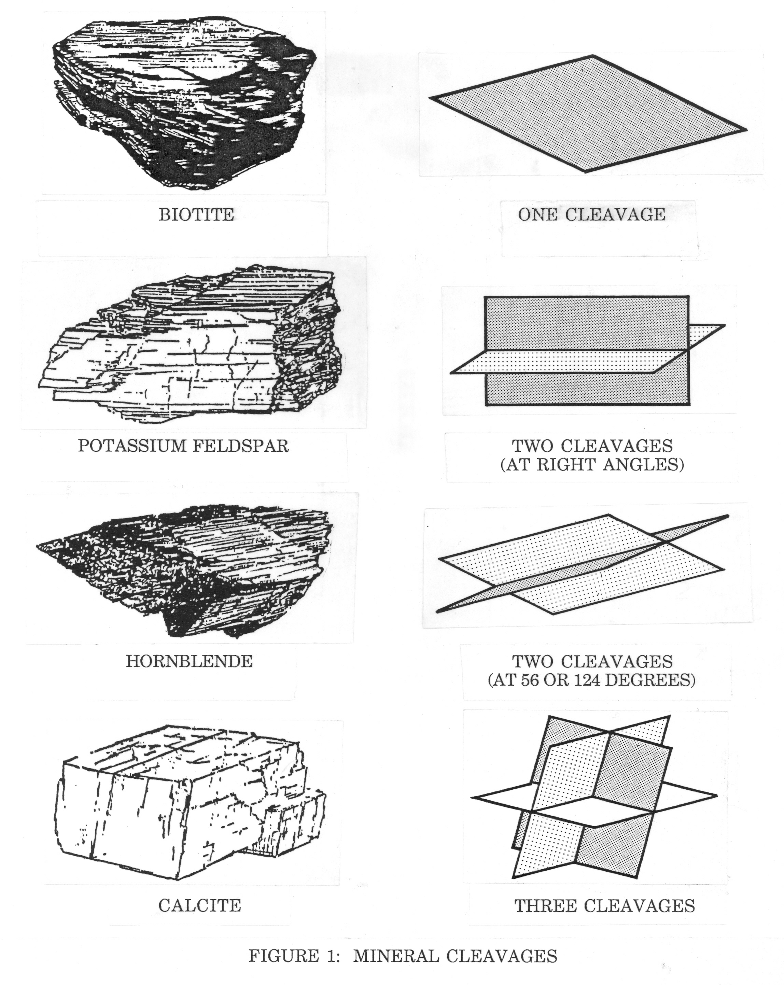

MINERAL ID GUIDE/CHART

QUESTION 1: Does the mineral have a metallic luster?

If YES, mineral = PYRITE (see below).
If NO = go to question 2

Name Sample # Hardness Color Cleavage?
1. PYRITE B-10 6 to 6.5 Always brassy yellow when fresh No (= Fracture)

Other Diagnostic properties: If tarnished = rusty brown. Forms cubic or 8-sided crystals. Most common in sedimentary rocks and metamorphic rocks. Common name = “Fools Gold.”

For minerals with NON-METALIC LUSTER:
QUESTION 2: Is the hardness of the mineral < 5.5?

If YES see mineral descriptions below.
If NO go to Question 3.

Name Sample # Hardness Color Cleavage?
2. MUSCOVITE B-4 2-3 colorless to Yes = perfect cleavage
light yellow (1 direction)

Diagnostic properties: Thin sheets, light color and low hardness. The cleavage in this mineral is so strong it breaks apart very easily into very thin sheet. Distinguished from biotite by its lighter color (found in all rock classes). Transparent and colorless in thin sheets.

3. BIOTITE B-5 2-3 brown to black Yes = perfect cleavage (1 direction)

Diagnostic properties: Thin sheets, dark color, and low hardness. The cleavage in this mineral is so strong it breaks apart very easily into very thin sheet. Distinguished from muscovite by its darker color (found in all rock classes).

4. CALCITE B-11 3 usually white Yes – very strong
to clear (3 directions = rhombic)

Diagnostic properties: Reacts with HCl, low hardness and the rhombic cleavage (shaped like a squashed cube). Most common in sedimentary and metamorphic rocks.

5. HALITE B-13 2.5 usually clear Yes – very strong
to white (3 directions = cubic)

Diagnostic properties: NO reaction to HCl, low hardness and cubic cleavage. Salty taste; common name = rock salt or table salt). Most common in sedimentary rocks.

For minerals with NON-METALIC LUSTER and HARDNESS > 5.5:

QUESTION 3: Does the mineral have cleavage?

If YES see mineral below.
IF NO see Question 4.

Name Sample Hardness Color Cleavage?
6. POTASSIUM B-2 6 white, gray, Yes (2 directions)
FELDSPAR or salmon

Diagnostic properties: Softer than quartz, yet harder than a knife blade, no reaction to HCl and some cleavages. See discussion of striations below to distinguish from plagioclase (found in all rock classes).

7. PLAGIOCLASE B-3 6 white (Na) to Yes (2 directions)
FELDSPAR black (Ca)

Diagnostic properties: Commonly plagioclase is confused with potassium feldspar; but, plagioclase will generally exhibit "striations" or parallel grooves which may be seen by the naked eye; NOTE: a hand lens is often needed to see the striations. The calcium-rich varieties have a dark gray to black color that enables one to distinguish the calcium feldspar from the lighter colored sodium plagioclase (found in all rock classes).

8. HORNBLENDE B-6 5-6 dark brown to black Yes (2 directions)
(a.k.a. amphibole)

Diagnostic properties: Very common in igneous rocks and metamorphic rocks. The cleavage is more pronounced in hornblende than in augite. Commonly the grains of hornblende are longer than they are wide. (A member of the amphibole mineral family).

9. AUGITE B-7 5-6 usually black Yes (2 directions)
(a.k.a. pyroxene) sometimes = blackish-green

Diagnostic properties: Augite is commonly mistaken for hornblende and vice versa. Both are dark minerals with similar hardnesses. However, the cleavage is significantly different. Augite commonly occurs in short, stubby grains as opposed to the elongated hornblende grains. Augite is found in all rock classes, but is most commonly found in dark igneous rocks (A member of the pyroxene mineral family).

For minerals with NON-METALIC LUSTER and HARDNESS > 5.5, and NO CLEAVAGE

QUESTION 4: What color is the mineral?

See descriptions below:

Name Sample # Hardness Color Cleavage?
10. QUARTZ B-1 7 usually white, No (= fracture)
colorless or gray
(but may be any color)

Diagnostic properties: Quartz is a very common mineral in all classes of rocks. It is distinguished by its high hardness and lack of cleavage (found in all rock classes). Note: may be many different colors. Forms 6-sides crystals and pyramids.

11. OLIVINE B-8 7 olive to gray-green No (= Fracture)

Diagnostic properties: Sugary-green texture is common, with relatively high hardness. Associated with the dark (mafic) igneous rocks (i.e. basalt, gabbro, and "ultramafics" -dark colored rocks with little or no feldspar). Gemstone variety = peridot. Glassy luster.

12. GARNET B-10 7 to red, orange No (= Fracture)
7.5 and brown

Diagnostic properties: Usually reddish-brown to orange in color, with high hardness. Many times it will occur as small crystals in rocks. Hexagonal Crystal faces are common (but no cleavage when broken). Most commonly found in metamorphic rocks.

