Lecture & Reading Guide for the Marginocephalia (the "Frilled" dinosaurs)
Suborder Ceratopsia & Subrder Pachycephalosauria

What Key Evolutionary Novelties/ Unique Characteristics are shared by the Marginocephalia

What general characterizes are displayed by the Marginocephalia?

In what time periods did these animals live and in which were they the most common?

How did the animals in suborder Ceratopsia and Pachycephalosauria differ?

What are the main purposes scientists have suggest for the horns & frills found on the Ceratopsian dinosaurs?

How did body size and frill of the Ceratposians change over time?

What are the 2 main purposes scientists suggest for the thick, boney roof of skull in the Pachycephalosauria?

Which group was most common in North America?

What have been suggested as the purpose of the horns of the dinosaur "Triceratops" and what evidence supports each theory.

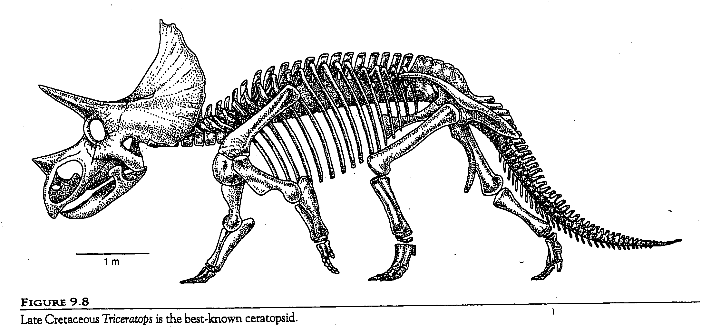
Order Ceratopsia

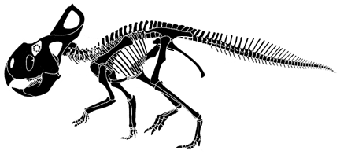

Order Pachycephalosauria
