Oceanography 101 Name(s):

Hurricanes and Global Climate Change - Part 2: The Global Carbon Cycle:

Nitrogen and oxygen are the major gases in the Earth’s atmosphere. All the remaining gases are “trace gases,” including carbon dioxide and the other “greenhouse gases.” Greenhouse gases prevent heat from escaping into space from the Earth’s surface, thus they cause the temperature of the atmosphere to slowly rise over time. Some greenhouse gases occur naturally in the atmosphere, while others result from human activities. Naturally occurring greenhouse gases include water vapor, carbon dioxide, methane, nitrous oxide, and ozone. Certain human activities (such as the burning of fossil fuel) add to the levels of most of these naturally occurring gases.
Global warming is the observed increase in the average temperature of the Earth’s atmosphere and oceans over the last 150 years. The prevailing scientific opinion is that most of this warming is due to human activities, which have resulted in an increase in greenhouse gasses in the Earth’s atmosphere. Global warming has long been predicted to result from increasing greenhouse gases in the atmosphere. Global surface air temperature has indeed increased in the past century, but at a rate less than 0.1°C/decade. Record global temperatures have been achieved several times in the last several decades, but a new record often exceeds the old record by only a few hundredths of a degree. What relevance, if any, do such small temperature changes have to most people? In the following exercises you will look at temperature records from a variety of location and examine the significance of these changes yourself.
More information can be found at the following links: for Carbon cycle & global change: http://www.globalchange.umich.edu/globalchange1/current/lectures/kling/carbon_cycle/carbon_cycle_new.html
An explanation of global warming: http://en.wikipedia.org/wiki/Global_warming
An explanation of how global temperatures are studied: http://www.giss.nasa.gov/research/briefs/hansen_04/

Part 2A: Carbon Dioxide (CO₂) Levels in our Atmosphere over Time
The more carbon dioxide and the other greenhouse gases in the atmosphere, the more heat from the sun is trapped in the atmosphere. This graph is from measurements of carbon dioxide in the atmosphere from March, 1958 Mauna Loa observatory on Hawai’i. This site is thought to be the least polluted air on the Earth because there is no source of air pollution upwind for thousands of miles from Mauna Loa.
Figure 1. Atmospheric carbon dioxide concentration at Mauna Loa, Hawaii since 1958. (units are ppmv = parts per million by volume) Source: http://en.wikipedia.org/wiki/User:Dragons_flight/Images#Carbon_Dioxide
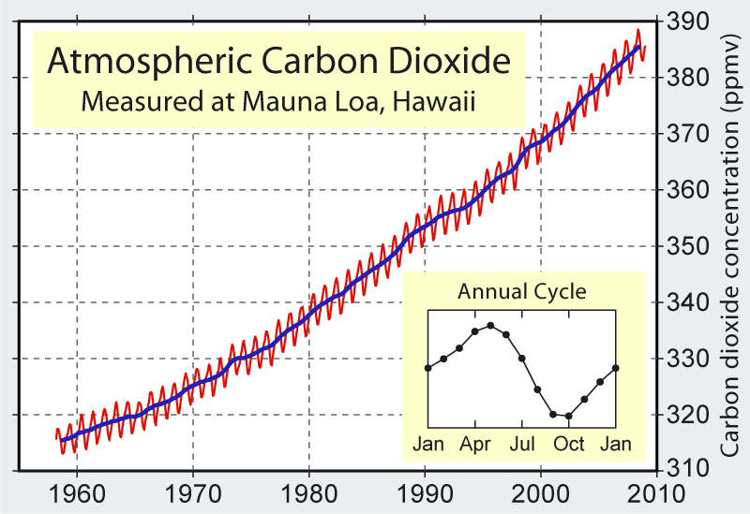

- How does the CO₂ level vary over the course of one year?

- How does the average annual CO₂ amount change?

- What advantages are there be to measuring CO₂ content in the atmosphere in Hawaii rather than an urban area such as United States?

- What is the total change in average annual CO₂ concentrations?

CO₂ at start of data collection ₌ - CO₂ Levels in 2010 = Total Change in CO₂

- Exactly many years has this data been collected (note: data is still being collected today) .

- What is the average rate of change in CO₂ concentration per year shown on this graph:

Average Rate of Change (= total change ÷ Year of data collection)

The wiggles seen on the graph in Figure 1 result from seasonal changes in CO₂ concentration. This is driven by changes during the winter season of the Earth’s Northern Hemisphere (which has more land mass and a higher population than the Southern Hemisphere).

- Suggest 2 reasons why CO₂ concentration would increase when it is winter in the Northern Hemisphere. (Hint: consider what happens to plants in the winter time and how this would affect CO₂ levels in the atmosphere and consider how the behavior of humans changes in the winter time.)

Most scientists have said that this increase in CO₂ is due to human emissions and the destruction of the rain forests. It is possible that some of the variation could be due to natural variations in carbon dioxide. To fully understand the issues related to greenhouse gases and global change, we need to examine the past to see if CO₂ levels have changed over time and if so, to what extent. We can use ice cores for Antarctica to understand past variations in trace gases. As snow falls it traps small amounts of air in the spaces between the snowflakes. Some of this gas forms small bubbles as the snow metamorphoses into glacial ice. These bubbles become fossil atmospheres providing us with a means to examine the gas content of the atmosphere thousands of years in the past.
Of primary interest to those studying global change and our present atmosphere, is the abundance of carbon dioxide and methane, the primary natural greenhouse gases. The graph below is the carbon dioxide concentration from an Antarctica ice core through the last approximately 650,000 years.

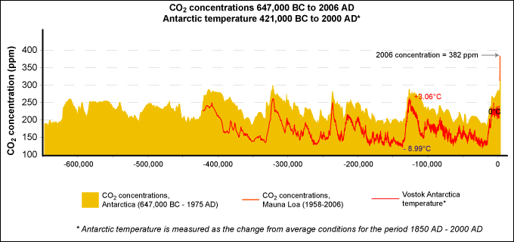

Figure 1: Fluctuations in temperature (black line) and in the atmospheric concentration of carbon dioxide (gray area) over the past 647,000 years. The vertical bar at the end is the increase in atmospheric carbon dioxide levels over the past two centuries and before 2007. Vertical Axis Units: ppm = parts per million (by volume). Horizontal axis = years.
To see this figure in color go to: http://www.epa.gov/climatechange/science/pastcc_fig1.html
- What are the maximum and minimum CO₂ levels before “0” years ago,
and what is the natural range (difference between max and min) in CO₂ ?

- What is the minimum number of years it takes for the natural system to change from a high CO₂ levels to a low for CO₂ levels?
Date of local CO₂ maximum - date of local CO₂ minimum CO₂ = yrs.

Part 2B: Regional Temperature Records (the United States):
Below is a figure showing the annual and five-year running mean surface air temperature in the contiguous 48 United States (= 1.6% of the Earth's surface) since 1880 compared to the mean (average) temperatures from 1951-1980. This is kind of an odd way to show the data, but it allows us to look for see how average temperatures have changed over the last century. Each square represents the average temperature for one year. The wiggly line represents the average temperatures over a 5-year period. Although this kind of graph does not show the actual temperatures, it allows you to look for potential long-term changes in temperature over time.

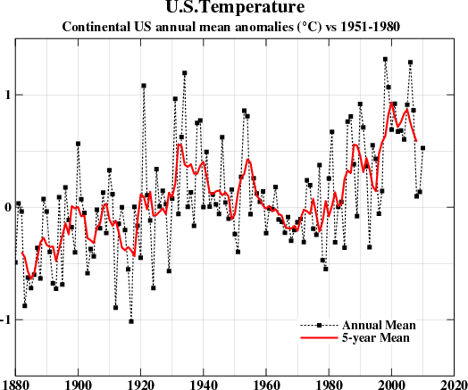
Average
Temperature
Anomaly
°C
Year

You can find the actual data for this figure and a color version of the graph on the web at: http://data.giss.nasa.gov/gistemp/graphs/.

Examine the graph, or check out a table of the data shown above (on the website) and fill in the table below. Then determine whether or not temperature show a trend over time (is there a definite change?).

Time period | Number of years with mean Temp. > 0° to +1° above normal | Number of years with mean Temp. more than +1° above normal | Number of years with mean Temp. < 0° to -1° below normal
1880-1899
1900-1919
1920-1939
1940-1959
1960-1979
1980-1999
2000-2009*
Trend over time?  (circle one) | Warming / Cooling, No-trend | Warming / Cooling, No-trend | Warming / Cooling, No-trend
*Note the last time-period is much shorter than the others. You will need to take this into consideration when looking for evidence of trends

Date
Hottest year
Hottest 5-year period
Coldest year
Coldest 5-year period

- How do the dates of the coldest year compare to date of the coldest 5-year period (are the dates the same)?

- How do the dates of the hottest year compare to date of the hottest 5-year period.

- If you are looking for trend through time is it easier to identify changes in yearly mean temperatures or the 5-year mean temperature?

- Overall, do your conclusions change depending on which time-frame you examine? Explain your answer.

- On average have temperatures risen or fallen since 1900 in the US? After looking at this data set, do how confident are you that there is an overall change in temperature? Explain your answer.

We must be careful not to use one example to try and explain global temperatures. Consider what other factors beyond global climate change may be influencing temperatures in USA.

- How has the amount of paved streets and parking lots changed in USA since 1900? How would this affect temperatures that were measured in the middle of large cities (Hint: What is like to walk across a parking lot barefoot in summertime?)

Part 2C: Global Temperature Record

Below is a figure showing variations in GLOBAL annual since 1880 compared to the mean (average) temperatures from 1951-1980 average. The dotted black line is the annual mean and the solid red line is the five-year mean. The green bars show uncertainty estimates due to incomplete spatial sampling of data. Compare this graph to the one for USA and answer the questions below.

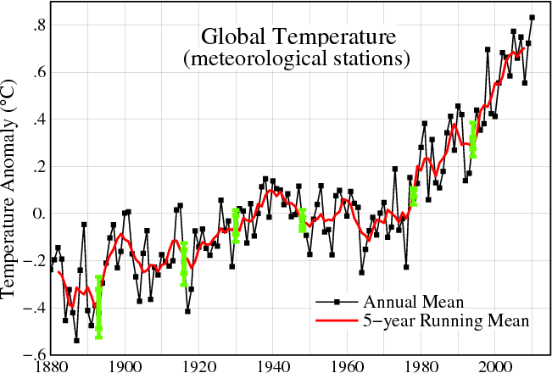
Year

For a color version of this graph or to see that data in table form go to: http://data.giss.nasa.gov/gistemp/graphs/

Fill in the table below based on the global temperature record:

Time period | Number of years with mean Temp. > 0° to +1° above normal | Number of years with mean Temp. more than +1° above normal | Number of years with mean Temp. < 0° to -1° below normal
1880-1899
1900-1919
1920-1939
1940-1959
1960-1979
1980-1999
2000-2009*
Trend over time?  (circle one) | Warming / Cooling, No-trend | Warming / Cooling, No-trend | Warming / Cooling, No-trend
*Note the last time-period is much shorter than the others. You will need to take this into consideration when looking for evidence of trends

- Based on the data above - Predict how many years will be > 0° to +1° above normal for the time period from 2000-2019:

- Compared to the US temperature data, are the trends shown by the global data set: stronger/ weaker/ or the same strength (circle one).

- Have global temperatures risen or fallen since 1900, and how much have they changed? .

- What is the size of the overall temperature changes in US and how does this compare to the size of the global temperature change?

- Are the years with the highest and lowest annual temperatures the same on both graphs? If not how much do they differ?

- Are the decades with the highest and lowest average temperatures the same on both graphs? If not how much to they differ (i.e. how much time is there between them)?

- Suggest a reason why temperature in USA are more variable than average global temperatures:

- How does the direction and variability of the global temperature the direction and variability of atmospheric CO₂ levels? Explain your answer and suggest a reason for any difference you observe.

Part 2D: The Effects of Global Warming on Washington State
Check out the Washington State Department of Ecology website: http://www.ecy.wa.gov/climatechange/ and consider the questions below:

- Click on the box labled “EFFECTS IN WASHINGTON” (Bottom Left side): List the 4 major impacts of climate change on Washington State. And give at least 2 specific examples of the results of each impact (you find the detail by clicking on the word for each effect).

- Major Impact:
Ex 1:
Ex 2:

- Major Impact:
Ex 1:
Ex 2:

- 3. Major Impact:
Ex 1:
Ex 2:

- 4. Major Impact:
Ex 1:
Ex 2:

